Exam Final Mock

Total Marks: 150
Time: 2 Hours

Question 1: MCQ’s, Fill in the Blanks, True or False Questions. [50 Marks]

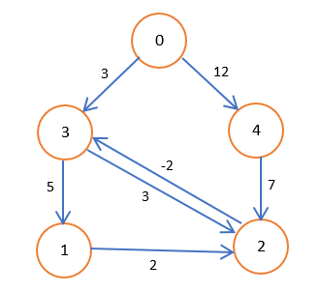
Question 2: Find the shortest path from source vertex(S=0) to all other vertices in a given weighted directed graph.

Question 3: What are flow networks with all its properties? What is maximum flow problem? Give Ford-Fulkerson algorithm and analyse its complexity? Find the maximum flow in the following network with source node A and sink node as J.:
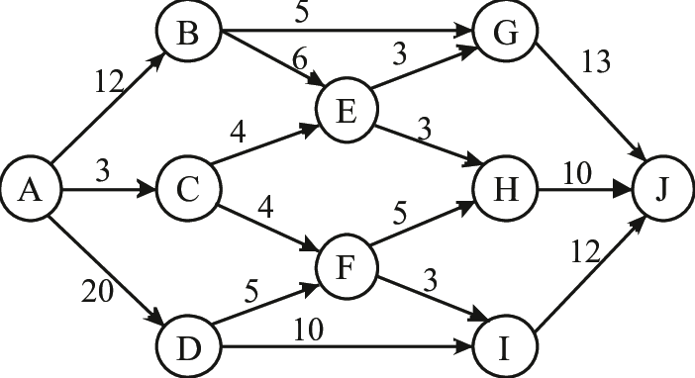

Question 4: What is minimum spanning tree? Give an O(|V|²) algorithm to find MST of a graph. V is the set of vertices in a graph. Find the MST of graph shown below using this algorithm.

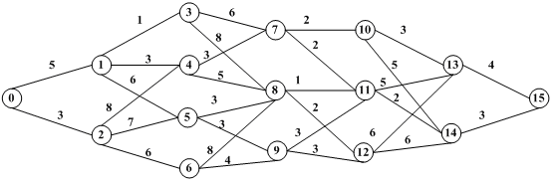

Question 5: Given a input sequence on integers [A1,A2,A3 …. An]. Write an efficient program to compute the following:
- Longest decreasing Subsequence.
- Longest Increasing Subsequence.

